Hospital Management System Phase 5

Report

Web Programming – CPAN 369 0NA

Justin Pimentel –

Myles Pritchard – N01182099

Date of submission: April 15, 2024

Table of Contents

Cover Page: Page 1

Table of Contents: Page 2

User Guide Pages 3-25:

Initial Setup: Page 3

Running the Application: Page 4

Navigating the Website: Page 5

Registering an Account: Page 6

Logging In: Page 7

Physician Related Instructions: Pages 9-13

Patient Related Instructions: Pages 14-20

Visit Related Instructions: Pages 21-26

Info Page Instructions: Pages 27-29

User Guide

Initial Setup

Use the unzipping software on your computer to extract the files from the folder to the desired location on your computer. Open Visual Studio 2022 click the option to open a project/solution.

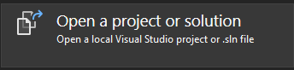

Find the location where you extracted the files. Click on the Hospital Management System.sln file to open the project.

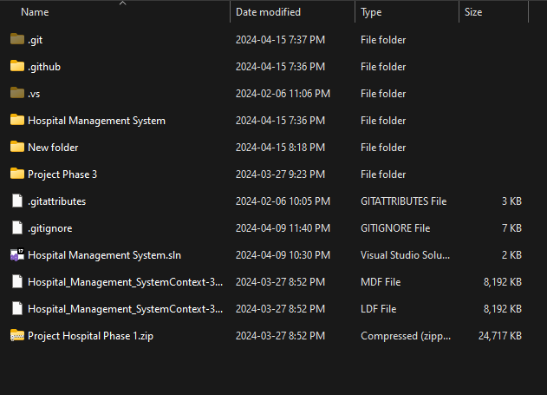

Running the Application

Once the application is open click on the https button in the top bar to run the application.

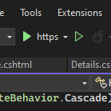

You should see the home page of the application (shown below):

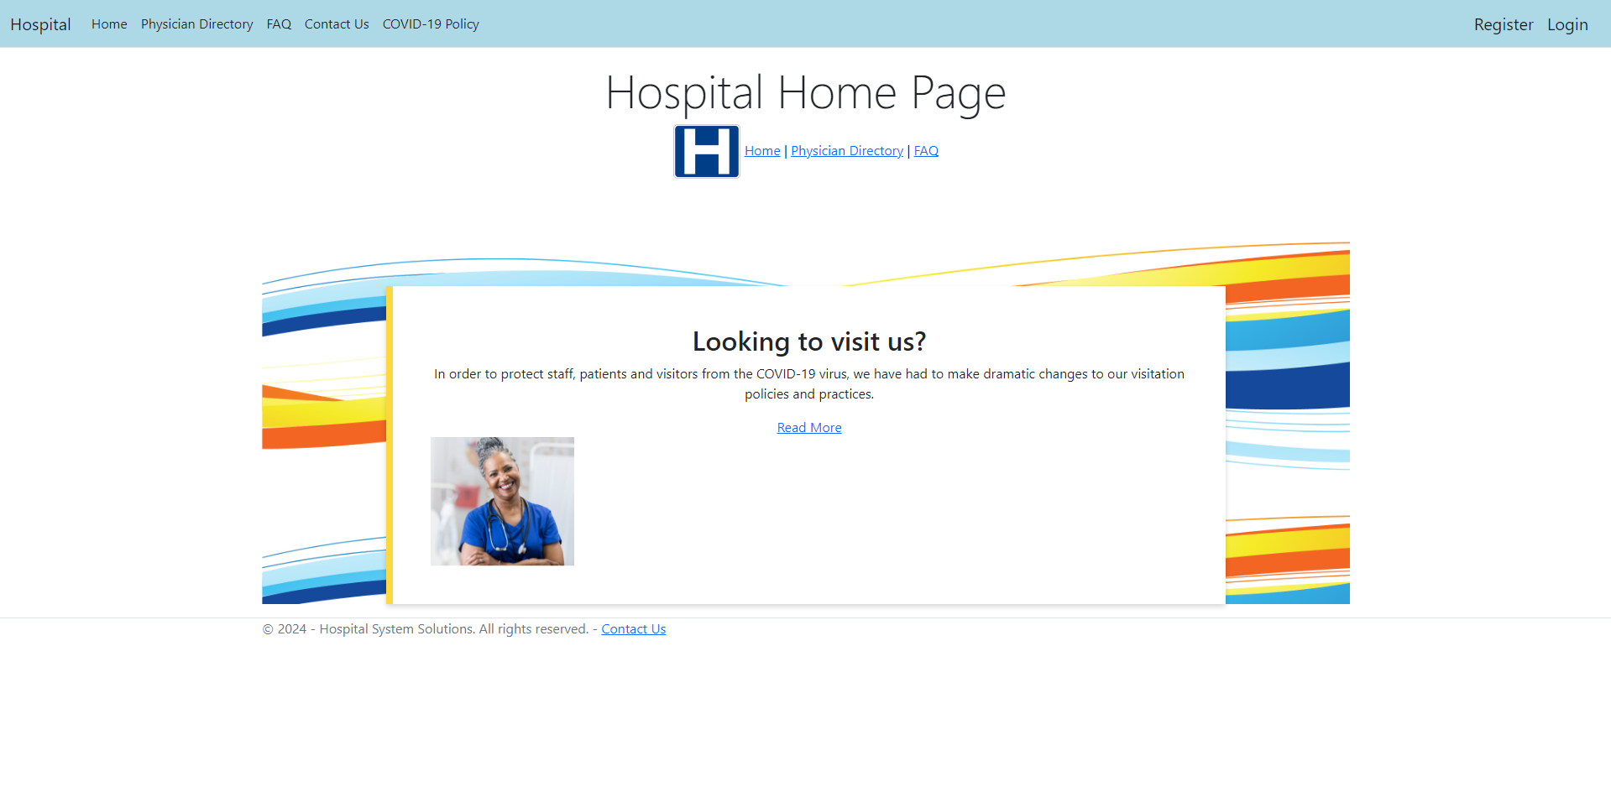

Navigating the Website

To navigate the website you can use either the top bar (Option 1) or the navbar listed under the title of the home page.

Option 1:



Option 2:



Registering for An Account

To register for an account click on the Register button in the top right of the page.

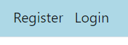

This will take you to the registration page, fill out the form and click the Register button to proceed with your registration. This will take you to this Register Confirmation page, click on the Confirm Account link to proceed.



After clicking you will see a notification confirming your email.

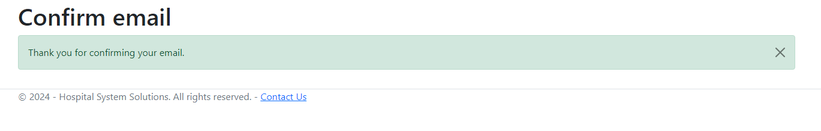

Logging In

After making an account you can click on the login button in the top right of the site to login.



This will take you to this Log In page where you will fill in the same info you registered with prior.

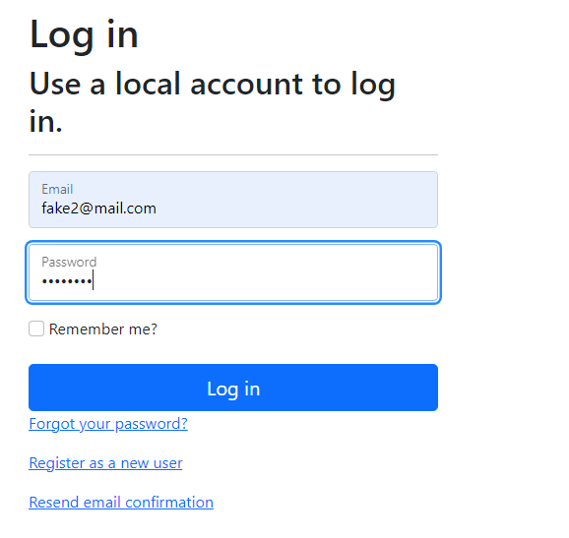

There are also redirect links if you would like to register a new user, have forgotten your password or need to resend the email confirmation.

You will know you were successful in logging when you get redirected to the home page and see the email you logged in with in the top right of the page.

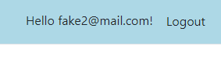

Now that you are logged in you will notice that you have more options on the navbar and top bar than you did before.

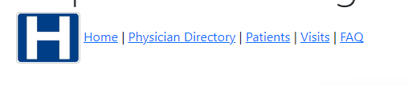



Physician Related Instructions

Accessing the Physician Directory

To access the physician directory click on the link in either the navbar or the top bar. You will see a page like the one below (the entries will vary depending on the database records of your local system)

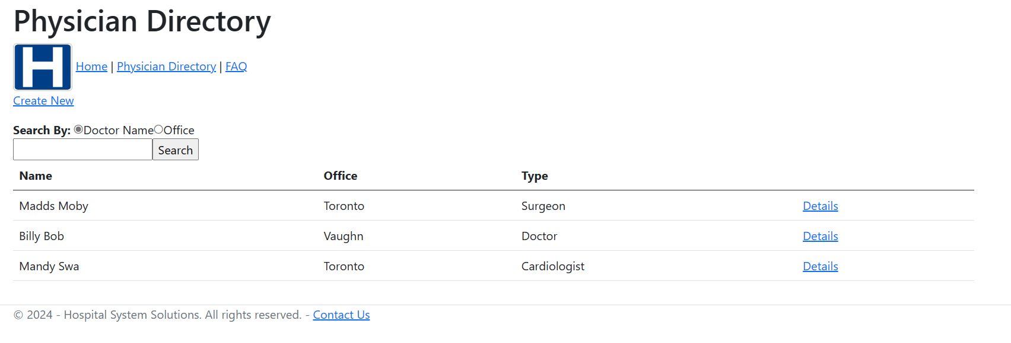

Creating a New Physician

To create a new physician navigate to the physician directory and click on the create new link. (NOTE: Must be logged in to do so):

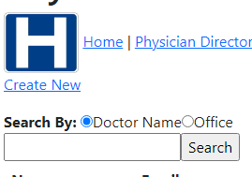

Fill out the form to and click save to create a physician

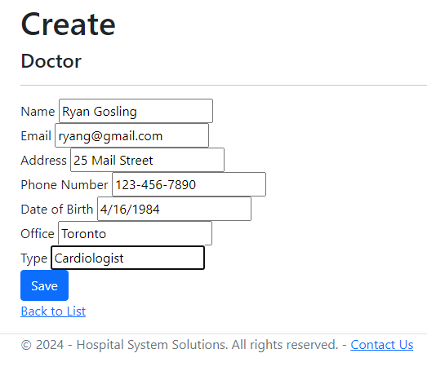

Once you have filled out the form click the save button to continue, you will see the Doctor you have created populated in the directory.

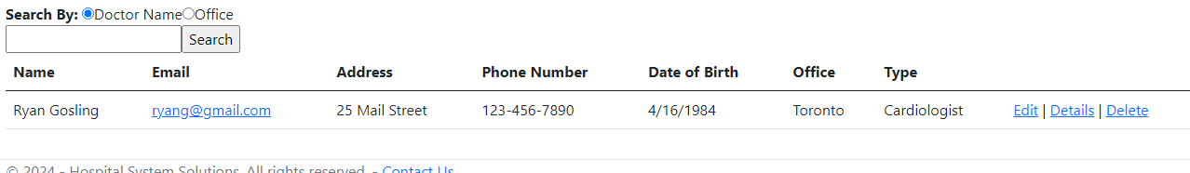

Editing an Existing Physician

Click on the Edit link next to the physician you would like to edit (NOTE: Must be logged in to do so):

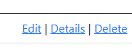

This will take you to a page similar to the creation page.

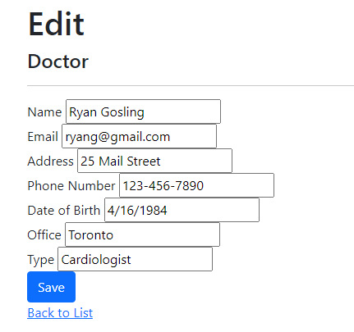

After making your desired changes click the save button, if you don’t wish to save your changes simply click back to list.

Physician Details Page

To navigate to the physician details page click on the details link next to your desired physician.

This will take you to the following page:

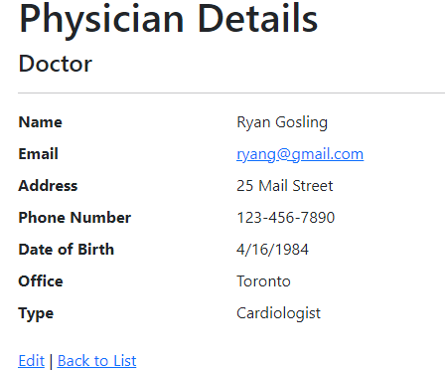

Deleting Physicians

To delete a physician from the directory click on the delete link next to the physician (NOTE: Must be logged in to do so):

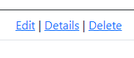

This will take you to a deletion confirmation page, from here you can either click on the red delete button to confirm the deletion or click back to list to cancel this action.

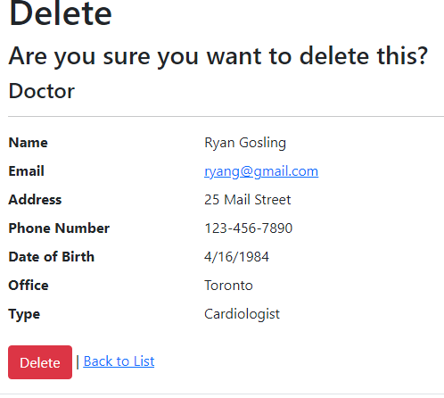

After deleting you will be navigated back to the physician directory and the physician in question will be deleted.

Patient Related Instructions

Accessing the Patient Directory

To access the Patient directory you can click on the Patient link either in the navbar or the top bar. (NOTE: Must be logged in to do so):





You will see a page like the one below (the entries will vary depending on the database records of your local system):

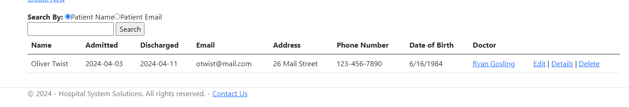

From this page you can navigate to the Patient’s Physician’s Details page by clicking on the Physician’s name.

Creating a New Patient

(NOTE: Must have at least one Physician created in the Directory to Create a Patient):

To create a new Patient navigate to the patient directory and click on the create new link (NOTE: Must be logged in to do so):

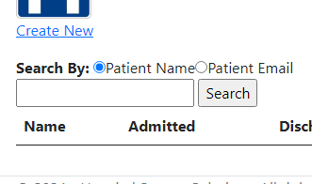

Fill out the form to and click save to create a Patient.

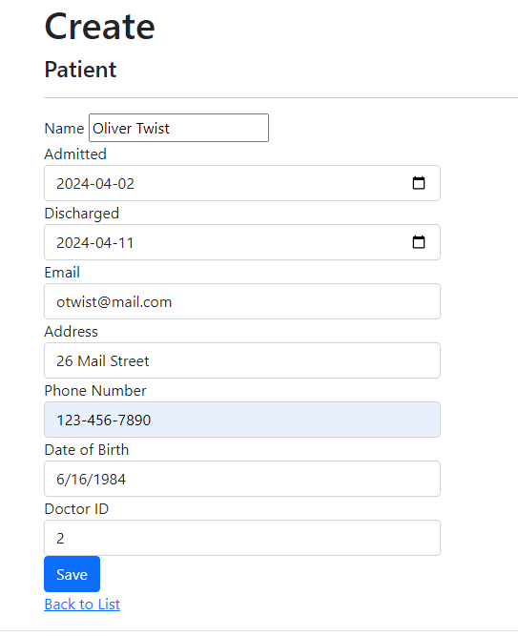

Once you have filled out the form click the save button to continue, you will see the Patient you have created populated in the directory.

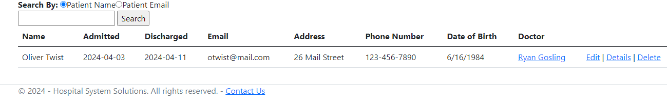

Editing an Existing Patient

Click on the Edit link next to the Patient you would like to edit (NOTE: Must be logged in to do so):



This will take you to a page similar to the creation page.

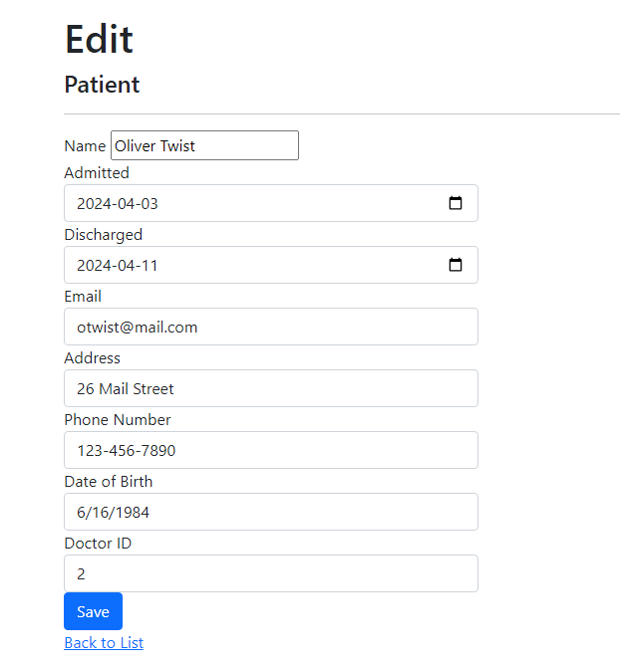

After making your desired changes click the save button, if you don’t wish to save your changes simply click back to list.

Patient Details Page

To navigate to the Patient details page click on the details link next to your desired Patient.

This will take you to the following page:

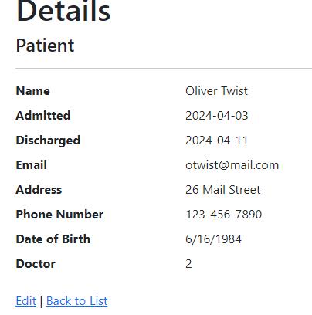

Deleting Patients

To delete a Patient from the directory click on the delete link next to the Patient (NOTE: Must be logged in to do so):



This will take you to a deletion confirmation page, from here you can either click on the red delete button to confirm the deletion or click back to list to cancel this action.

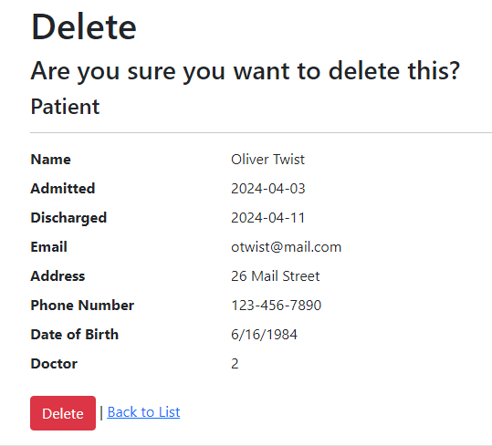

After deleting you will be navigated back to the physician directory and the physician in question will be deleted.

Visits Related Instructions

Accessing the Visits Directory

To access the Visits directory you can click on the Visits link either in the navbar or the top bar. (NOTE: Must be logged in to do so):





You will see a page like the one below (the entries will vary depending on the database records of your local system): 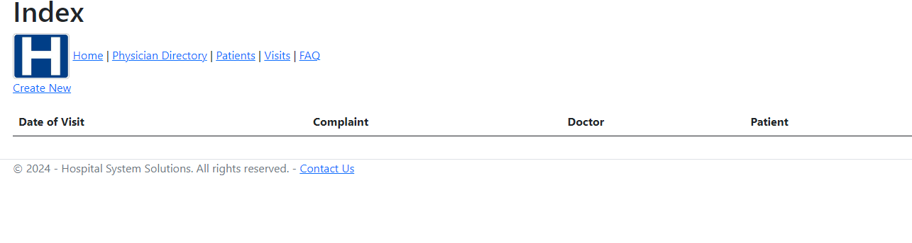

Creating a New Visit

(NOTE: Must have at least one Physician and at least one Patient created in the Directory to Create a Visit):

To create a new Visit navigate to the Visit directory and click on the create new link (NOTE: Must be logged in to do so):

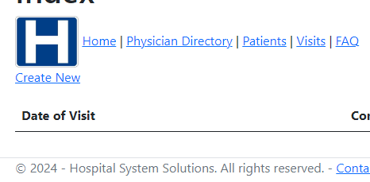

Fill out the form to and click save to create a Visit.

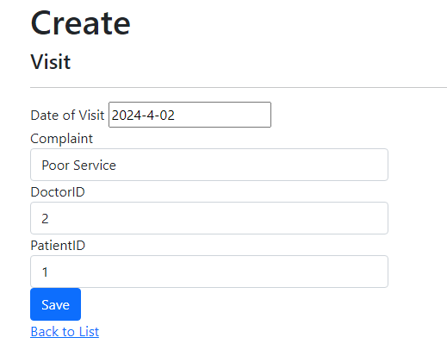

Once you have filled out the form click the save button to continue, you will see the Visit you have created populated in the directory.

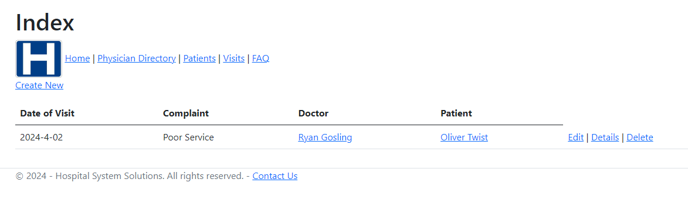

Editing an Existing Visit

Click on the Edit link next to the Visit you would like to edit (NOTE: Must be logged in to do so):



This will take you to a page similar to the creation page.

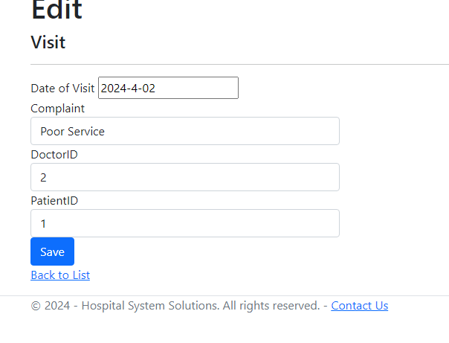

Visit Details Page

To navigate to the Visit details page click on the details link next to your desired Visit.

This will take you to the following page:

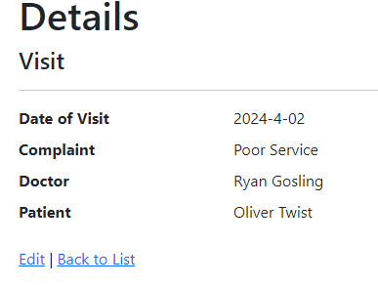

Deleting Visits

To delete a Visit from the directory click on the delete link next to the Visit (NOTE: Must be logged in to do so):



This will take you to a deletion confirmation page, from here you can either click on the red delete button to confirm the deletion or click back to list to cancel this action.

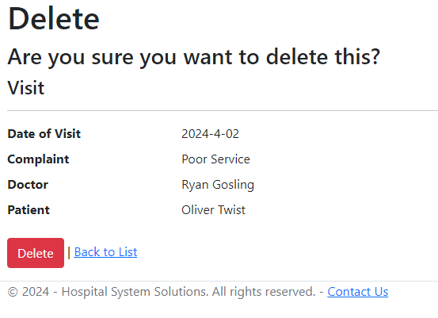

After deleting you will be navigated back to the Visits directory and the Visit in question will be deleted.

Info Pages

Contact Us Page

To Navigate to the Contact Us page click on the Contact Us button on the top bar



This will take you to the Contact Us Page:

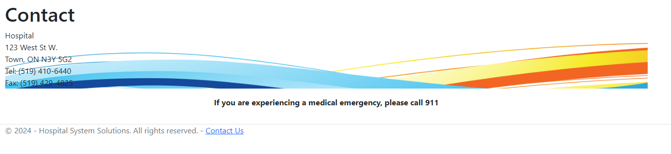

Covid-19 Policy Page

To Navigate to the Covid-19 Policy page click on the Covid-19 Policy Page button on the top bar



This will take you to the Covid-19 Policy Page:

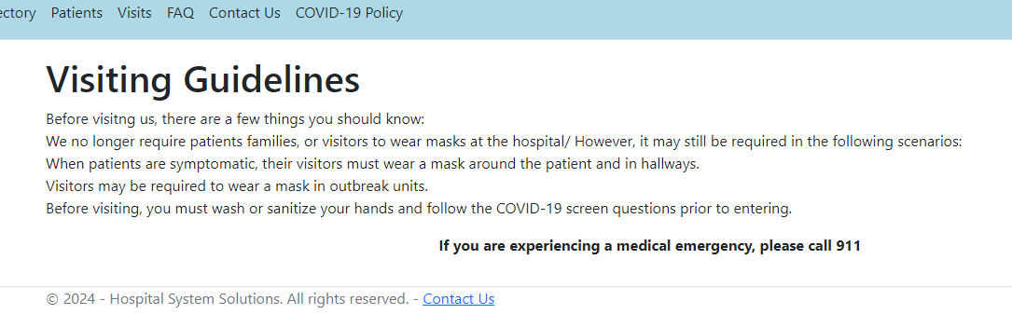

Home Page

To Navigate to the Home Page click on the Home Page button on the top bar



This will take you to the Home Page:

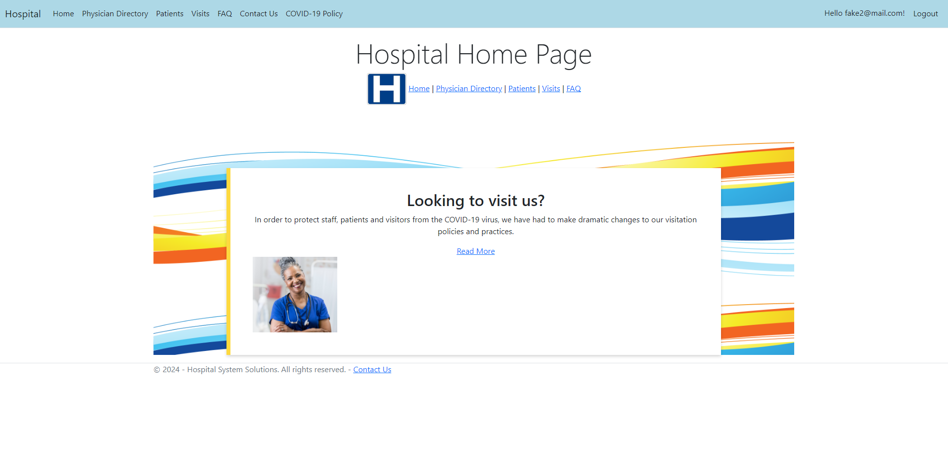

FAQ Page

To Navigate to the FAQ Page click on the FAQ button on the top bar



This will take you to the FAQ Page:

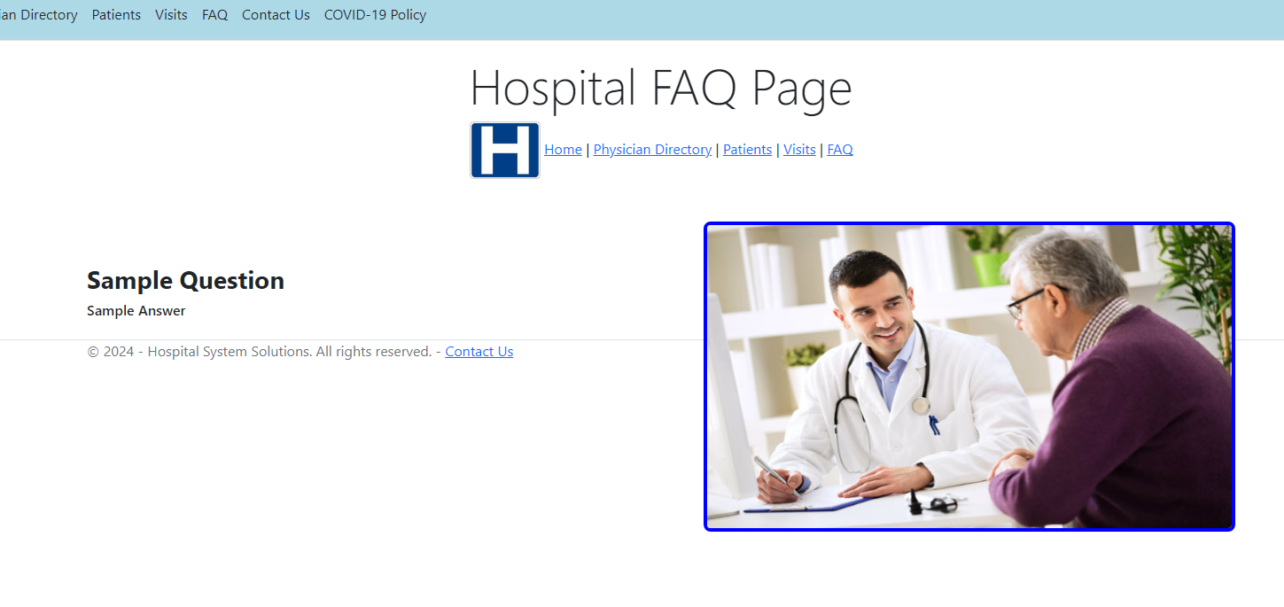

This concludes the instructions for this website.